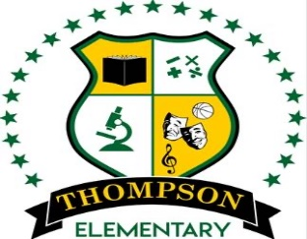 Ruby L. thompson Elementary SCHOOL
Erica Brame-Manuel, Principal/Chante Gary, Assistant Principal

A-TEAM
Weekly MEETING Agenda

Principal
Erica Brame-Manuel
Administrative Assistant
Samuel Braziel
Assistant Principal
Chante Gary
Teacher Specialist
Nastassya White
Counselor
Carvalyn McClellan

“Flying to Higher Altitudes”

Ongoing Reminders:
- Be Present during all transitions
- Be on time for duty
- Be Proactive
- Be Nice
- Have Fun

Nastassya White, Teacher Specialist/ Carvalyn McClellan, Counselor
6121 Tierwester Street Houston, TX 77021 713-746-8104 Fax 713-746-8104
Meeting Topics
Date/Time: Quarter II Meeting Agenda
January 26, 2023 (2:00 PM)
 | Agenda Item | Time Allotted | Presenter | Notes/Outcome
1. | Review Meeting Norms
2. | Welcome
3. | Temperature Check
3. | Parent Support (Participation and Communication)
4. | Start, Stop & Continue
5. | Open Floor Items:  - Spring Events: Daddy, Daughter dance, Muffins with moms, Spring Fest and Field Day  - Communication
6 | Needs from Admin

Campus-Wide Meeting Norms:
Come to Grow
Come to Trust
Come to Contribute
Come to Prepare

Campus Mission Statement:
We are dedicated to improving academic outcomes, school culture, and community engagement by enhancing students’ educational experience through rigorous and differentiated instruction, technology integration, and instilling critical thinking skills, to develop responsible citizens in a global society.

_____________________________________________________ ________________________________________________

_____________________________________________________ ________________________________________________

_____________________________________________________ ________________________________________________

